# **JOB ARCHITECTURE**

1. **Diagram**

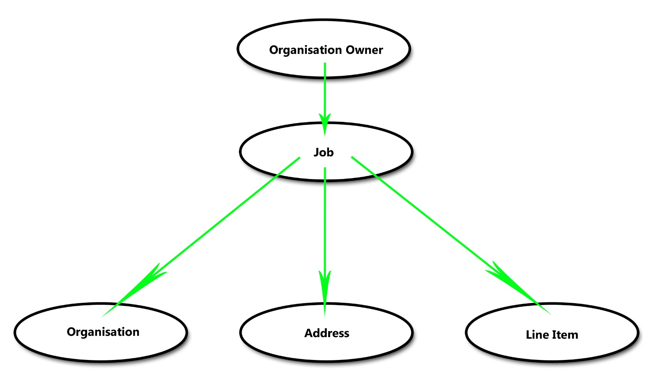

1. **Architecture Flow**

There are three parts to this diagram which can be identified as:

1. Job post of organization owner.
2. Fetch information.
3. Job Structure.

**II.a Job post of organization owner**

First, the owner of the organization will post a job and specify those required fields such as

Organization ID, Job Name, Job Code, Job Type and the likes. Note: All fields must be validated and

Checked if it is existing in the database before submitting the query to avoid errors and duplication

Of data in database. If an error occur, a message will return (e.g. “Organization ID doesn’t exist.”)

To inform the owner about what error is it.

**II.b Fetch information**

Job script will fetch information from organization, address, line item just to use as reference

Of employee to trace the address, job description and even organization ID is still needed to verify

Where company does the employee belong. The employee can also see what estimated time to make

Their job done, phone numbers, status, start date, End Date, and even quoted cost.

1. **Job Structure**

As of now, only the owner of the organization is allowed to ADD/EDIT/REMOVE job post and the Employee can only do is to be tracked and do their job as an employee of that organization. The way

This process works is listed below:

1. Organization Owner fill-up a job post form.
2. The Owner will submit the form.
3. The data sent by owner will automatically validate by the script.
4. Return a success or error message.
5. Owner can remove his job post as he pleases.
6. **Flow Chart Diagram**

